DCS Multiplayer – LAN Mode

DCS provides a dedicated server mode where the host PC does not require a GPU. Additionally scenery modules do not need to be purchased for the server, although all clients must have purchased the scenery modules.

The Server Must be able to connect to the outside world, and it would appear have port forwarding on port 10308 for UDP and TCP. This also means the Windows firewall needs to permit incoming traffic for that port. The server can be locally managed using either the shortcut that is installed on the desktop or using a browser pointing to port 8088.

Clients and Server must be running the same (or perhaps similar) code versions, which means when you go to join a multiplayer server, you’ll only see a subset of all servers as only servers with matching code versions are listed.

The Server defaults to private, but also can be flagged as private and also protected with a password.

Creating Multiplayer Missions

Ensure the aircraft is allowed to spawn hot so cold starts are not required
Test with Caucasus Map and SU25

When adding aircraft under skill – select Client
Click on the airbase and then under type select takeoff from parking-lot hot

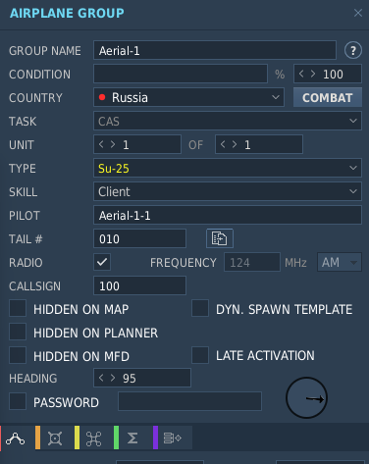
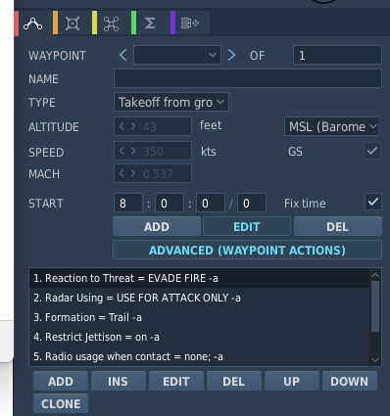

Additional Planes can be added – loadouts are dependant on task -

Adding Terrain Modules

The Terrain most be installed on the server to host a mission.

Adding a Terrain module

.\DCS_updater install SYRIA_terrain

After installing the module, and then adding and clicking load

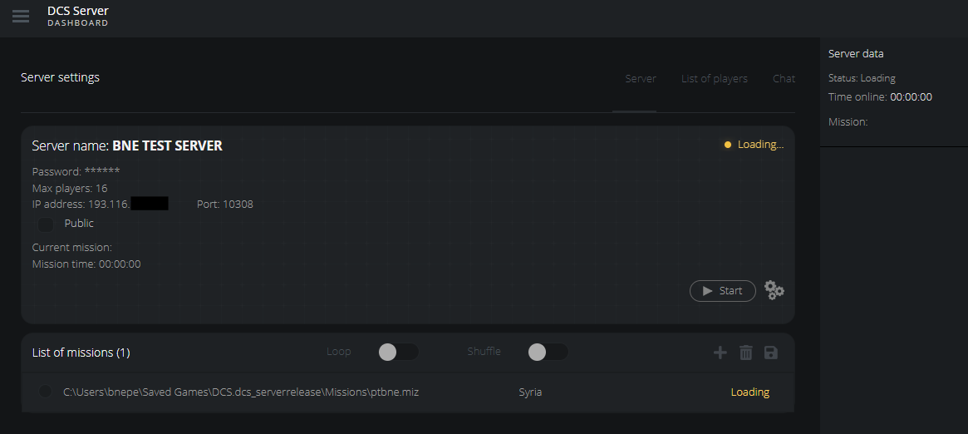

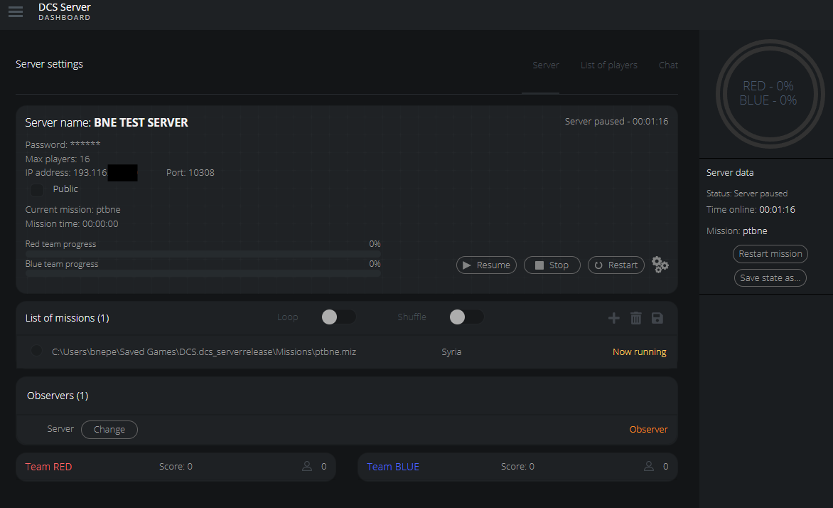

The Dedicated Server should be manageable using port 8088 – but currently returns a not found/

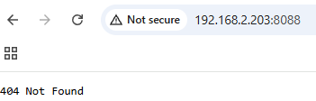

Joining a server
Whilst sometimes it appears you can select the aircraft to spawn to in the table list, other times if you select a collation and then aircraft you end up with just a view – you need to not only select the aircraft in the table but also then click on the desired aircraft on the map

Also the call sign needs to be unique - this is not your DCS Username but is set in the top right hand corner of the Multiplayer screen

You need to have an active license for the aircraft you to to fly – you can see if you are eligble to fly you should still be able to see the

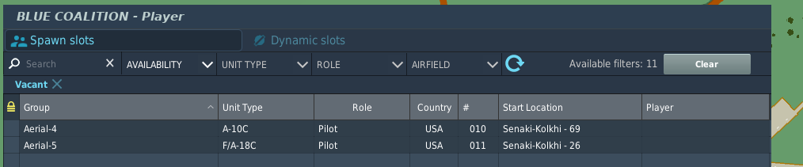
check what you are able to fly by using the Available Filter
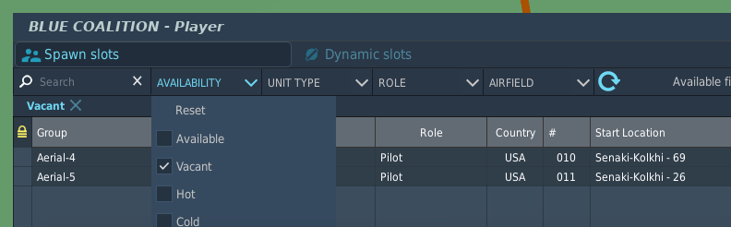
This means you are entitled
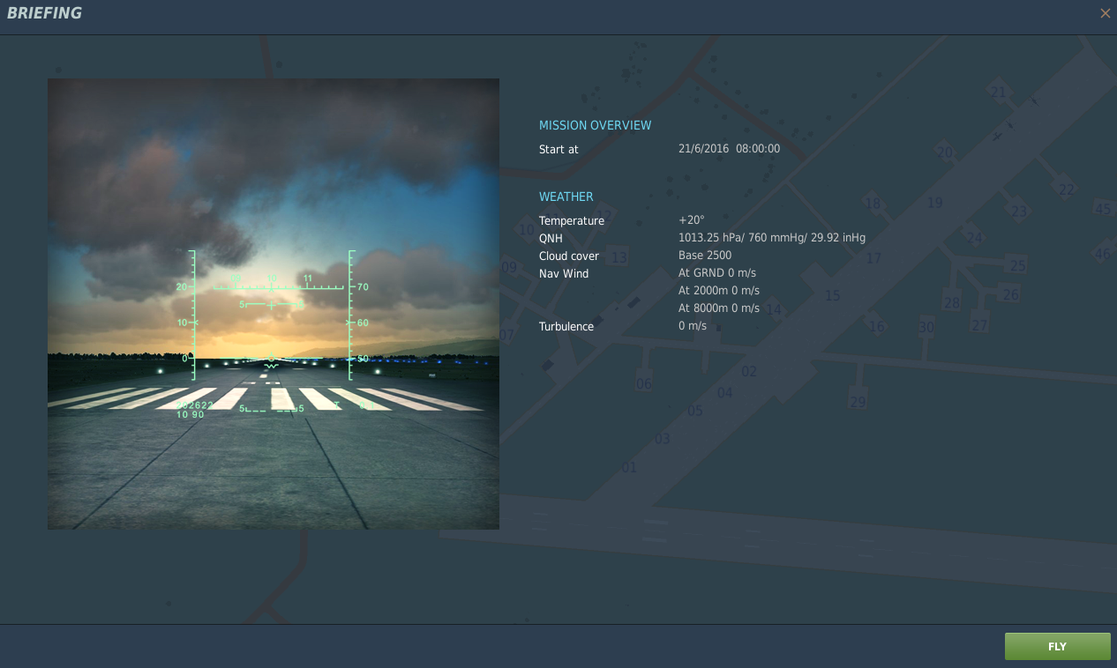
A cockpit or aircraft view then suggests you are good to go
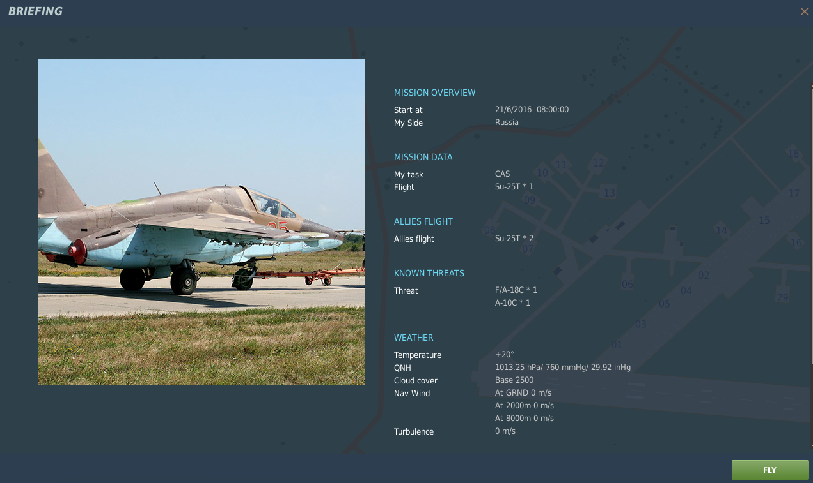
If things are amiss press escape and select role to reselect

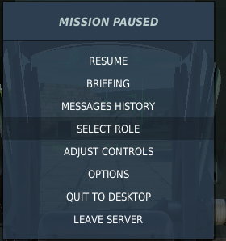

Non-Dedicated Server Option

Once a client joins a mission the server doesn’t start automatically, instead the Pause key must be used to start the mission

Dedicated Server Operation

Start the Dedicated Server
Use local GUI shortcut
Select the mission
Load the mission (takes a couple of minutes)
Then resume the server
The server active timer should then start incrementing
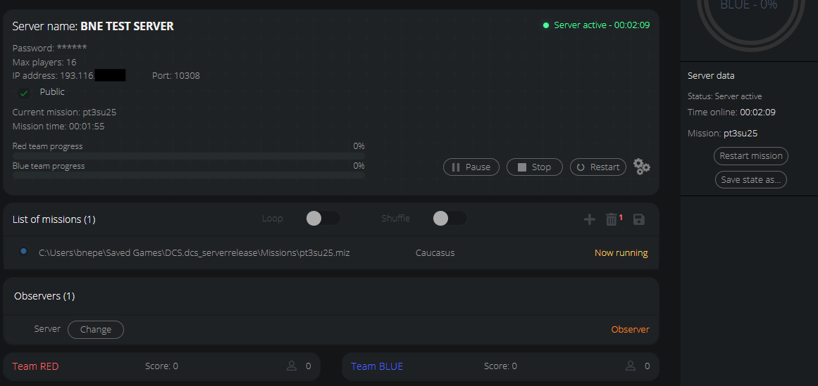

Currently testing
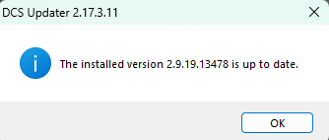

The server performs a similar workload to a client aside from not rendering the graphics that does mean a mission load will take a little time.

A basic health check can be performed by starting the server and then using the local web gui which is installed on the desktop. It prompts to connect to port 8088

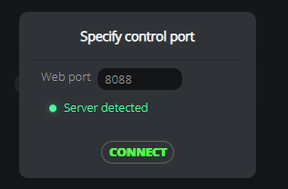

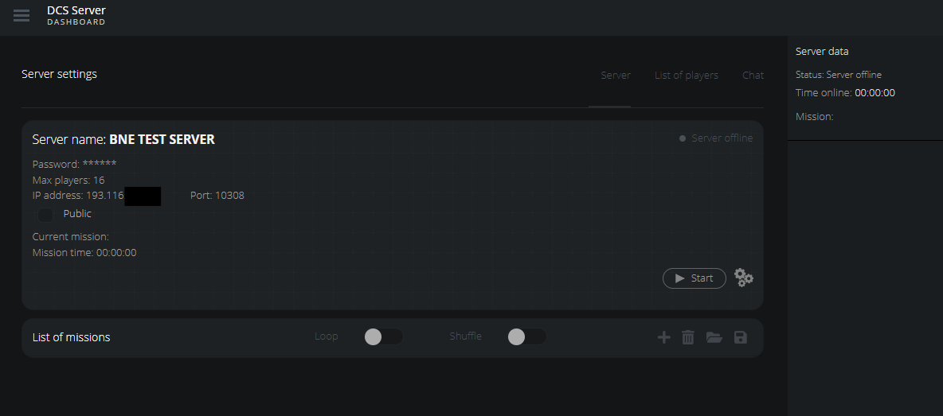
The server will not start unless a mission is selected

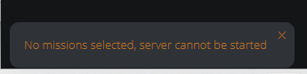
Initially the browse missions folder did not list anything as the installer had not created a missions folder in ‘Saved Games\DCS.serverrelease’ folder. Just copied folder from ‘Saved Games\DCS

The server status can be monitored from the primary DCS website, login in and then under profile you see Game Servers along with My Servers

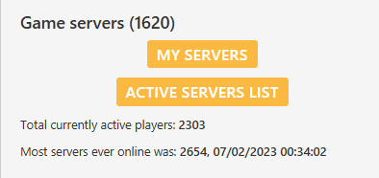

My Servers returns the status of active servers associated with your account, currently the environment is not in a happy state.
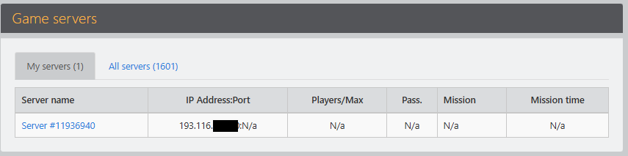

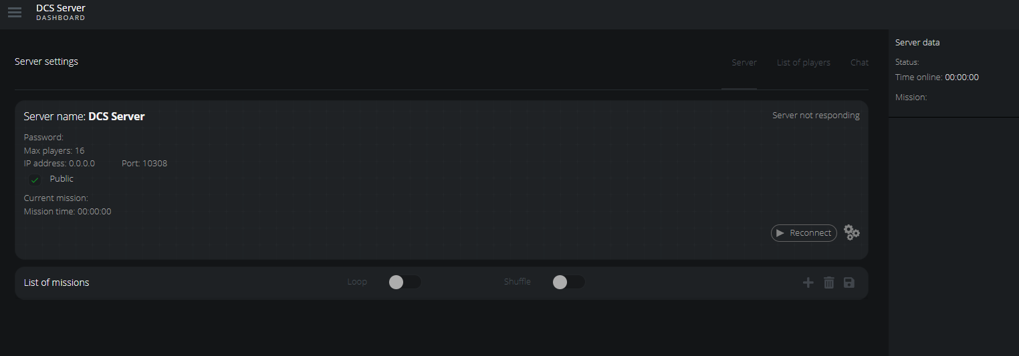

A mission must be loaded first

If it is marked as public it will in your servers list

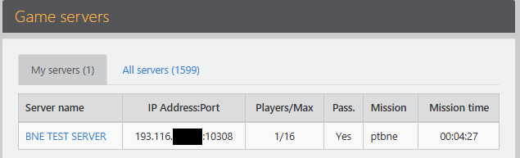

However when clicking on the Server name it still returns

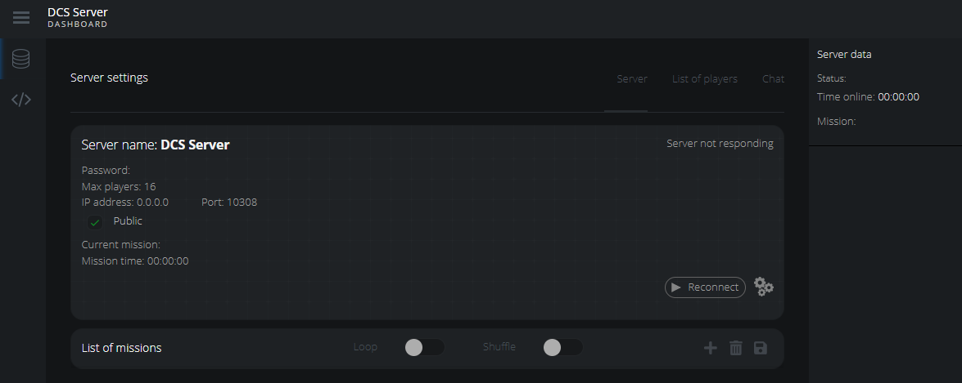

Lan users connect with just simply the IP Address of the Dedicated Server – a port number is not required.

Once a player has connected it is rolling
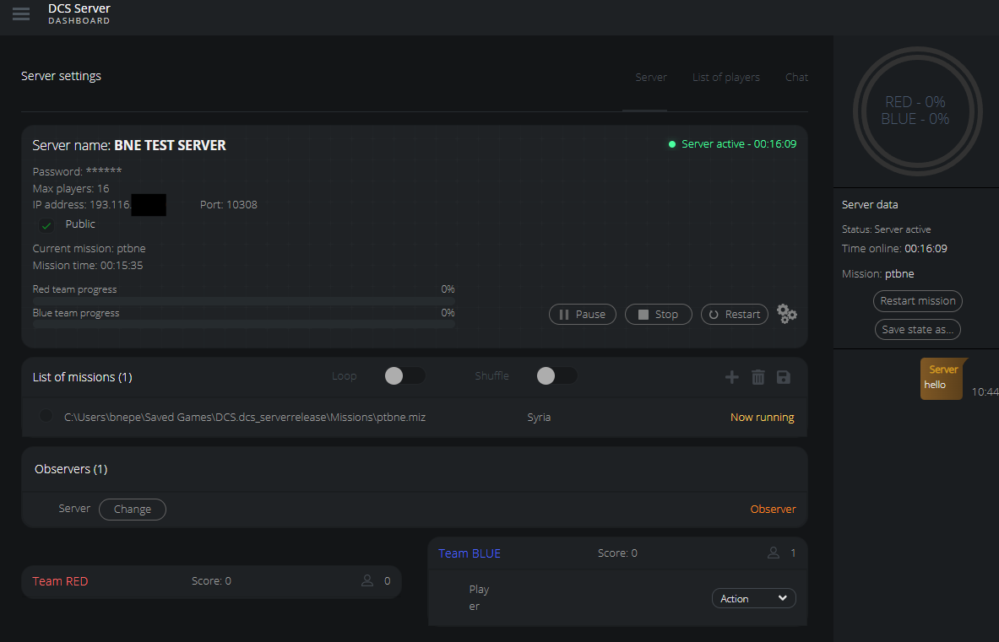

Configuration

If you have a single router with uPnP enabled no special configuration should be needed.

The network has a tp-link router connected to the NBN NTU, and a Meraki MX which means both need to be configured for port forwarding of port 10308. The inside address pool of the tp-link is 192.168.1.X which the first addresses being 192.168.1.100 which is the outside interface of the MX.

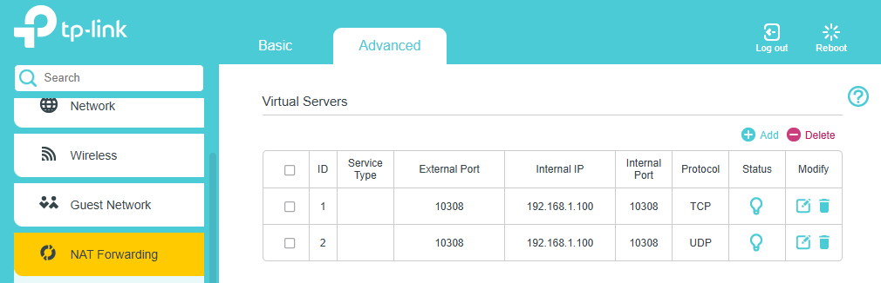
On the MX port forwarding is configured on the under the firewall rules, currently the test server has a IP address of 192.168.2.203

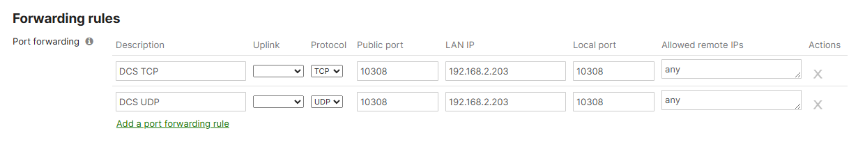

Troubleshooting

Validating Server Reachability from the Internet

https://www.yougetsignal.com/tools/open-ports/

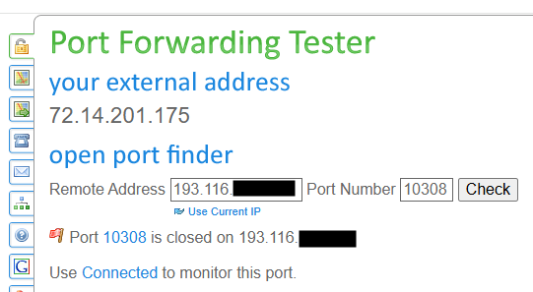

Under the tools menu on the MX real-time firewall logs can be used to validate if traffic is arriving

